Complete this form to become a Lender Agent utilizing HomeBridge in USDA’s Guaranteed Underwriting System (GUS). Lender Agents may enter applications into GUS, order new and/or re-issue credit reports and request preliminary GUS underwriting recommendations.
Brokers must be approved with Homebridge to request a Lender Agent role. Once the form is complete email to: hb-brokerapproval@homebridge.com
All of the following information is required for Homebridge to add a broker as a Lender Agent in GUS:

Broker Name:
Address:
Broker Tax ID:
GUS Username*:
*A username for an established GUS login account must be provided. See below to request GUS login from USDA
Homebridge will provide a confirmation email when the request has been processed.
Name/Title |  | Phone |  | Date

To create an eAuthentication ID for GUS access:
- Access USDA eAuthenticationat: https://www.eauth.usda.gov
- From left navigation menu click “Create An Account”
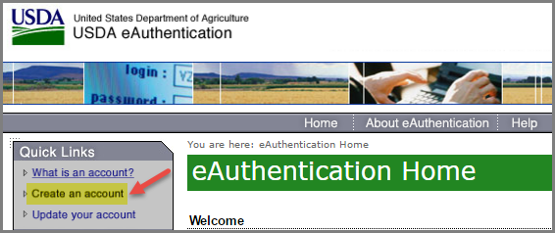
- Click “Register for a Level 1 Account”
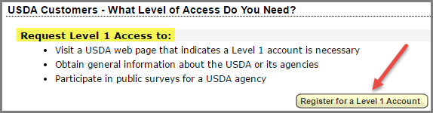
4. Complete all requested information - follow instructions on the Register for Your Account -- Level 1 form
5. Make sure to click "Activate" the account from the email sent from the eAUTH Help Desk
NOTE: If you do not receive the email to activate your account, check your spam/junk folder

